St Joseph’s N.S.

Wellbeing Policy 2024

Contents:

- Rationale
- Introduction
- Wellbeing Policy Statement and Framework for Practice
- Schools for Health in Ireland: Framework for Developing a Health Promoting School
- Looking at Our School: A Quality Framework for Primary Schools
- What is Wellbeing?
- Wellbeing Protective and Risk Factors
- The Role of the Teacher
- Multi-component Approach to Wellbeing Promotion
  - School Culture and Environment
  - Curriculum
  - Policy and Planning
  - Relationships and Partnerships
- Two-tiered Approach to Wellbeing Promotion
- Whole School Approach
  - Benefits of a Whole School Approach
  - Whole School Initiatives that Promote Wellbeing
  - Programmes and External Facilitators
- Individual and Targeted Support
  - The Student Support Team
  - External Agencies and Specialist Support Services
- Indicators of Success
- School Self-Evaluation Wellbeing Promotion Process
- Supporting the Implementation of the Wellbeing Promotion Process
- Continuous Professional Development
- Staff Wellbeing

Rationale
The promotion of wellbeing is central to the Department’s mission to enable children and young people to achieve their full potential and contribute to Ireland’s social, cultural and economic development. Schools play a vital role in the promotion of wellbeing through a range of activities and approaches to support the academic, physical, mental, emotional,

social and spiritual development of all children and young people. Our education system is key to equipping children and young people with the knowledge, skills and competencies to deal with challenges that impact on their wellbeing (Wellbeing Policy Statement and Framework for Practice, 2018).

In the school environment, social and emotional skills do not exist in isolation but interact with cognitive skills development. The role of the school is now understood as a place which develops the ‘whole child’, who should leave school with a balanced set of cognitive, social and emotional skills to face the challenges of the 21st century (OECD 2014). Schools play a key role in developing and enhancing young people’s wellbeing as they spend a large proportion of their time in school during their formative years. Children and young people learn more effectively and have better academic outcomes if they are happy in their work, believe in themselves and feel acknowledged and supported in their schools. National and international research highlights that the wellbeing of our children and young people is critical to their success in education and in life (Wellbeing Policy Statement and Framework for Practice, 2018).

St Joseph’s NS has already developed innovative approaches to wellbeing promotion supported by strong leadership and quality teaching and learning. We aim to further support children by optimising opportunities to learn about wellbeing. As well as being a place of academic learning, our school provides opportunities to develop friendships and social networks, to respectfully encounter diversity and access support structures.

This policy displays existing and developing work in wellbeing promotion in St Joseph’s NS. Its implementation is an ongoing, reflective and self-evaluative process that aims to focus on supporting children in having a sense of purpose and fulfilment, and the skills necessary to deal with life’s challenges. It also aims to be responsive to the changing needs of the school and the children in our care.

Introduction

This policy sets out the vision and ambition of St Joseph’s NS to ensure that the experience of our children from the early years throughout their primary education will be one that enhances, promotes, values and nurtures their wellbeing. Key to this ambition is building on the good practice already in place and the capacity of our school to assess, understand, evaluate and promote the key factors that will lead to optimal promotion of student wellbeing in our school setting.

We adopt a preventative, multi-component, continuum of support approach to the promotion of wellbeing with the provision of both whole school and targeted interventions that promote school-based protective factors and reduce school-based risk factors. We are committed to the ongoing review and development of the four key areas and indicators of

successful wellbeing promotion - school culture and environment, teaching and learning, policy and planning, and relationships and partnerships. This involves all members of the school community engaging in a collaborative process of change to improve specific areas of school life that impact on wellbeing.

Our wellbeing policy is:
- Child-centred: The wellbeing needs and the best interests of our children are a central focus of this policy. This requires us to respect and value the voice of children and young people and foster their belonging and connectedness to our school community.
- Fair and inclusive: All children receive fair and inclusive opportunities to develop their wellbeing in ways that are responsive and suitable to their particular needs and contexts. Practices are tailored and relevant, building on the existing strengths of children, school staff, families and school communities.
- Evidence-informed: This policy promotes the use of evidence-informed practice, which brings together local experience and expertise with the best available evidence from research.
- Outcomes focused: This policy promotes continuous improvement practices and the use of data relating to outcomes to guide practice in our school in relation to the promotion of wellbeing for all children.
- Partnership/Collaboration: The wellbeing of our children is a shared responsibility. Working in partnership with parents, guardians, school staff and external agencies is key to ensuring this policy is implemented.

Documents which have informed our Wellbeing Policy planning:
- Wellbeing Policy Statement and Framework for Practice (DES, 2018)
- Schools for Health in Ireland: Framework for Developing a Health Promoting School (HSE, 2013)
- Looking at Our School: A Quality Framework for Primary Schools (DES, Inspectorate, 2016)
- Well-Being in Primary Schools Guidelines for Mental Health Promotion (DES, DOH & HSE, 2015)
- Aistear: The Early Childhood Curriculum Framework (NCCA, 2009)
- Bí Cineálta: Procedures to Prevent and Address Bullying Behaviour for Primary and Post Primary Schools

Wellbeing Policy Statement and Framework for Practice
The Department’s Wellbeing Policy Statement and Framework for Practice assists schools in ensuring that wellbeing promotion is embedded within the school’s existing practice. The school’s review and development process using the Wellbeing Policy Statement and Framework for Practice provides guidance and practical resources to assist in the further enhancement of whole school approaches to wellbeing promotion.

The Wellbeing Framework for Practice outlines:
- Key areas of wellbeing in education
- Indicators of success in each of these areas
- Statements of effective practice to guide schools
- Suite of online wellbeing resources

Schools for Health in Ireland: Framework for Developing a Health Promoting School
The Health Promoting Schools process provides a comprehensive approach for school self- evaluation in:
- Environment (physical & social)
- Curriculum, Teaching and Learning
- School Policy and Planning
- Partnerships (family and community links)

A health promoting schools approach is a way of thinking and working that is adopted by all in the school to make it the best possible place to learn, work and play (Queensland, 2005).

Looking at Our School: A Quality Framework for Primary Schools
Looking at Our School articulates the Department’s holistic view of learning in schools. The framework sees wellbeing as both an enabler of learning and an outcome of learning. It emphasises the need for children and young people to develop a broad range of skills, competencies and values that enable active citizenship, lifelong learning and personal wellbeing. The framework asserts that in providing good quality learning experiences, teachers need to also consider children and young people’s wellbeing and that effective school leadership and management involves creating and maintaining a positive, secure and healthy culture where the holistic development of all children and young people is enabled. Looking at Our School also provides a coherent approach to improving outcomes and experiences for all children and young people. It is used to assist schools in embedding self- evaluation processes and reflective practices and it provides a structure for implementing new initiatives. The domains and standards of Looking at Our School can therefore support schools in promoting and enhancing the wellbeing of all members of the school community.

What is Wellbeing?

“Wellbeing is present when a person realises their potential, is resilient in dealing with the normal stresses of their life, takes care of their physical wellbeing and has a sense of purpose, connection and belonging to a wider community. It is a fluid way of being and needs nurturing throughout life.” (World Health Organisation, 2001)

Wellbeing is multidimensional:
- Physical
- Social
- Mental
- Emotional
- Spiritual

The Mental Health Foundation (2002) suggests that children who are mentally healthy possess the ability to:
- develop psychologically, emotionally, socially, intellectually, spiritually

- initiate, develop and sustain mutually satisfying interpersonal relationships
- use and enjoy solitude
- become aware of others and empathise with them
- play and learn
- develop a sense of right and wrong
- resolve (face) problems and setbacks satisfactorily and learn from them (Alexander, 2002)

The science of wellbeing is studied as Positive Psychology. Positive psychology is underpinned by Professor Martin Seligman’s PERMA Theory of Wellbeing (2011). PERMA Theory outlines 5 core elements of wellbeing.

Table 1: PERMA Theory of Wellbeing
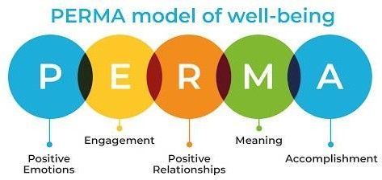

In St Joseph’s NS we focus on building these 5 elements of wellbeing by:
- Increasing and prioritising positive emotions
- Teaching emotional regulation skills
- Encouraging children to utilise their skills
- Providing challenging activities to facilitate growth
- Identifying and using character strengths
- Promoting and supporting inclusion
- Communicating high expectations
- Fostering positive relationships
- Providing support
- Teaching life skills
- Facilitating connection to the school community
- Improving self-efficacy
- Celebrating success

Wellbeing Protective and Risk Factors
Risk and protective factors relating to wellbeing promotion that are specific to our school setting have been identified. Protective factors have been found to promote positive outcomes for children and young people, even when they have been exposed to risk factors (Cooper, Jacobs, 2011). In St Joseph’s NS, we implement a preventative wellbeing promotion process

that has a focus on strengthening school-based protective factors and minimising school- based risk factors.

In St Joseph’s NS Wellbeing Protective Factors include:
- positive relationships with peers and teachers - including positive teacher classroom management strategies and a sharing of positive behaviour management practices with parents
- a sense of belonging, security and connectedness to our school through the creation of a positive school climate and participation in school and community activities
- opportunities for social and emotional learning including the development of attention and planning, self-awareness, emotional regulation, relationships, responsible decision making and problem solving skills
- opportunities for the development of knowledge and skills providing a sense of mastery and self-efficacy
- fostering expectations, recognising contributions, effort and achievement and providing opportunities for success
- protocols and support systems that proactively support children and their families should difficulties arise
- opportunities to develop the necessary skills to cope with using online technology in a safe and appropriate way
- wellbeing of school personnel and professional development for teachers and staff

In our school setting, Wellbeing Risk Factors include:
- disengagement, absenteeism, isolation and alienation
- violence/aggression, bullying and relationship difficulties
- low achievement/learning difficulties/special educational needs including social, emotional and behavioural needs
- cultural differences
- school transitions
- poor connection between family and school
- inconsistent discipline
- lack of opportunity to develop social and emotional learning, including problem solving and coping skills

The Role of the Teacher
The role of the teacher has been found to be paramount to children’s wellbeing and reaches beyond teaching and learning. The relationship that teachers develop with the child has a key influence on wellbeing development. Access to ‘one good adult’ who can guide and support a young person at a vulnerable time is an identified protective factor. The presence of one supportive adult is critically important to the child’s wellbeing, sense of connectedness, self- confidence and ability to cope with difficulties. Teachers are sometimes that ‘one good adult’ acting as a protective force in a child’s life.

The classroom teacher is the best placed professional to work sensitively and consistently with students and he/she can have a powerful impact on influencing students’ attitudes, values, and behaviour in all aspects of wellbeing education.

It is essential that all staff continue to develop their competence and confidence in the promotion of wellbeing. This can be achieved through accessing continuing professional development (CPD) which includes the sharing of expertise and learning, and having opportunities to model and engage in collaborative working. The curricular elements of wellbeing promotion are delivered by staff who are trained for this purpose having completed the relevant CPD training e.g. Friends for Life.

Multi-component Approach to Wellbeing Promotion
The Department advocates a multi-component approach to wellbeing promotion to ensure that all of the key areas that contribute to wellbeing promotion in schools are given a focus. The Department considers the following four areas as key areas for action in wellbeing promotion:
- Culture and Environment
- Curriculum (Teaching and Learning)
- Policy and Planning
- Relationships and Partnerships

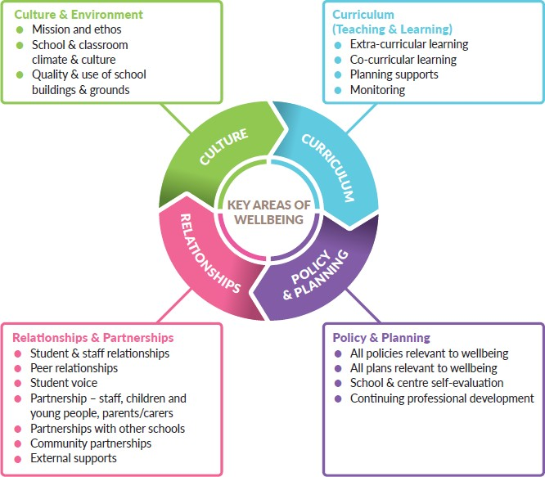
Table 2: Four Key Areas of Wellbeing Promotion

School Culture and Environment
St Joseph’s NS aims to cultivate an environment that enhances wellbeing for all who learn, work and visit. Our school environment is one that consciously fosters warm relationships, encourages participation, develops pupil and teacher autonomy and provides clarity of boundaries, rules and positive expectations.
St Joseph’s NS provides a safe, secure and stimulating environment that encourages and supports pupils, staff and members of the whole school community, both in and out of school.

We provide a climate in which positive relationships, respect and consideration for others prosper, and where individuals are encouraged to make a vital contribution through their personal skills and qualities.
Our school leaders actively promote wellbeing in St Joseph’s NS. Our In-School Management team strive to create a culture and climate which is accepting and supportive for staff, parents and students. Through nurturing quality relationships within the school we facilitate the wellbeing of staff members and students as well as fostering a shared responsibility for promoting positive wellbeing.

Curriculum
Wellbeing promotion is central to all areas of teaching and learning in St Joseph’s NS. The teaching and learning is democratic, inclusive, engaging and differentiated. We deliver an integrated curriculum that recognises the richness and uniqueness of the individual and the importance of the quality of teaching and learning experiences.

Wellbeing promotion is addressed across the curriculum through:
  - Aistear
  - SPHE
  - Physical Education
  - Religious Education
  - Science
  - Nurture

Aistear: The Early Childhood Curriculum Framework (NCCA, 2009) encompasses four themes
- Wellbeing, Identity and Belonging, Communication, Exploring and Thinking.

Social, Personal and Health Education is central to pupil development in its broadest sense and is an essential part of school curriculum. The SPHE curriculum in St Joseph’s NS strongly supports the social and emotional wellbeing of our pupils, by placing an emphasis on children’s social and emotional skills, attitudes, behaviour and therefore learning performance. SPHE encompasses the development of emotional literacy which is the ability to understand emotions, listen to others and empathise. This includes provision of safe, secure and comfortable environments that enable children to share their concerns.

Key characteristics of the SPHE programme delivered in our school:
  - a lifelong process
  - a shared responsibility between family, school, health professionals and the community
  - based on the needs of the child
  - spiral in nature
  - effective and consistent in delivery
  - developed in a combination of contexts
  - engages children in activity based learning (NCCA 1999).

Policy and Planning
St Joseph’s NS regularly reviews our school policies for staff and pupils that are in accordance with the school aims, philosophy, vision and ethos. All aspects of the school planning and self- evaluation process in our school incorporate a health and wellbeing dimension.

Wellbeing promotion is addressed in school policies and plans including but not limited to:
- Aistear
- Physical Education
- Religious Education
- SPHE
- Science
- Code of Behaviour
- Child Safeguarding
- Critical Incidents
- Health and Safety
- Anti-bullying
- Acceptable Use Policy
- Special Educational Needs
- Transition Planning

Relationships and Partnerships
St Joseph’s NS continues to develop strong partnerships with parents/guardians and the wider community, which is a central part of the wellbeing process. We efficiently engage with appropriate agencies and specialist services to advise, support and contribute to health and wellbeing, teaching and learning.

The following stakeholders collaborate regularly:
  - Parents/Guardians
  - Board of Management
  - Patronage
  - Parents Association
  - Student Committees
  - Local schools
  - Voluntary/sports/arts groups
  - State agencies
  - Community groups
  - Support services

In accordance with the Wellbeing in Education Framework for Practice and using the six-step School Self Evaluation process, St Joseph’s NS has identified Culture and Environment as our key area focus.

Targets For All

- The wellbeing of the whole school community is central to the school’s ethos and mission statement. School leaders and management actively promote wellbeing.
- The relationship between academic achievement and a child’s wellbeing is understood by all children and staff in the school.
- St Joseph’s NS recognizes that wellbeing is as important for the staff as it is for the children.
- The school building, grounds, classroom, bathrooms and workspaces are well maintained and appropriately furnished creating a welcoming and warm environment.

Targets For Some
- Staff, children and young people are welcoming and inclusive of those from different cultural backgrounds
- School is proactive in encouraging the professional development of teachers in relation to wellbeing
- School environment is modified to meet the needs of children with additional/complex needs

Two-tiered Approach to Wellbeing Promotion
In St Joseph’s NS we adopt a preventative, two-tiered approach to wellbeing promotion, with interventions at both universal whole school and individual targeted levels.

Whole School Approach
Our whole school approach involves all members of the school community engaging in a collaborative process of change to improve specific areas of school life which impact on wellbeing. By adopting a whole school approach, we aim to produce a wide range of educational and social benefits for our pupils, including improved behaviour, increased inclusion, improved learning, greater social cohesion, increased social capital and improvements to mental health and wellbeing.
In St. Joseph’s NS, we embrace School Support for All as a whole school approach that focuses on promoting wellbeing for all members of the school community. School Support for All is a process of prevention, effective mainstream teaching, early identification and intervention for children who are showing mild or transient signs of difficulty. Students flourish where there is a whole school approach to supporting their growth and wellbeing.

Our Whole School Approach involves:
  - raising awareness of wellbeing promotion
  - regular review and development of policies relating to wellbeing such as critical incidents, bullying, child protection etc
  - professional development for school staff in wellbeing promotion
  - implementing the SPHE curriculum which includes a focus on whole school approaches to wellbeing and health promotion
  - implementing universal evidence based programmes and interventions
  - establishing school structures for supporting staff and students including the school support team
  - establishing mechanisms such as student councils to ensure that the voices of children are heard
  - planning, collaborating and appropriate sharing of information between schools when children are making the transition into primary school or moving into post-primary school
  - liaising with appropriate external agencies and services eg NEPS psychologists, NCSE etc.

Benefits of a Whole School Approach
Adopting a whole school approach has been found internationally to produce a wide range of educational and social benefits for individual children including:

  - Better learning results for pupils
  - Increased pupil self-esteem
  - Improved behaviour
  - Lowered incidence of bullying
  - Increased inclusion
  - School environment is safer and more secure
  - Improved relationships within the school
  - More involvement of parents/guardians
  - Better use of outside agencies
  - More proactive in promotion of staff wellbeing

Whole School Initiatives that Promote Wellbeing
St Joseph’s NS implements a number of programmes and initiatives that support the wellbeing of our pupils, including but not limited to:
  - Aistear: The Early Childhood Curriculum Framework
  - SPHE Curriculum (RSE Month, Stay Safe Month, Friendship Week, Wellbeing Week)
  - Weaving Wellbeing
  - Continuum of Support Model

  - Student Committees: Student Council
  - Wellbeing Wall
  - Project based learning
  - Outdoor learning
  - Partnership with the local Sports Development committee
  - External PE coaches e.g. GAA
  - School Swimming lessons
  - Healthy Eating- Glanmore
  - Active School Flag
  - Health Promoting Schools Initiative - Barnardos
  - Monthly whole-school assemblies
  - Themed weeks (e.g. Maths Week, Science Week, Wellbeing Week etc)
  - Promoting the Arts – Christmas Concerts, entry into art competitions (Texaco), Art displayed within the school etc

Programmes and External Facilitators
The use of programmes and external facilitators can play a role in supplementing, complementing and supporting a planned comprehensive approach to wellbeing promotion.

Programmes and external facilitators accessed in St Joseph’s NS:
  - are part of a whole school approach and address an identified need
  - are delivered to class groups with the involvement of school staff and the appropriate involvement of parents/guardians
  - enhance protective factors which predispose students to positive outcomes in the face of adversity such as: facilitating supportive adult-pupil relationships, strengthening life skills, helping students believe in their capacity to overcome hardship and building a sense of mastery over life circumstances
  - adopt a planned implementation process, for example, incorporate needs analysis, use evidence informed programmes and track and evaluate outcomes for students
  - are implemented and used in our school in a sustained way over a number of years in order to bring about lasting effects and benefits

Individual and Targeted Support
In line with best practice, the Continuum of Support model delivered within our school offers a flexible framework within which we can address all educational needs, including the wellbeing needs of our pupils.

Table 3: Continuum of Support

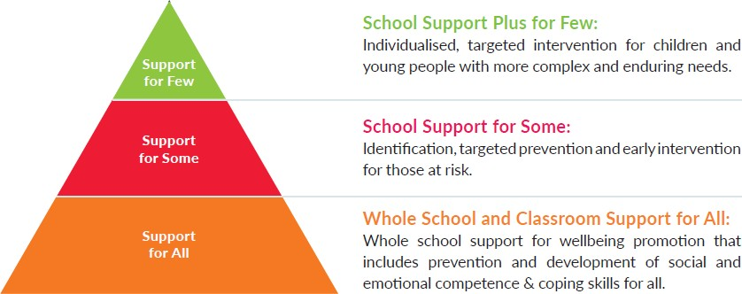

The Continuum of Support recognises that individual children and young people can have different needs at different times. Those at greater risk and with greater needs may require more specific and targeted support, in addition to the support provided to all children and young people in their class-based groups.
Children and young people with additional needs and vulnerable groups are particularly at risk in the area of wellbeing (NCSE, 2014). The National Educational Psychological Service (NEPS) supports schools to promote the wellbeing and mental health of all children and young people. While supporting all, NEPS prioritises support for those at risk of educational disadvantage and those with special educational needs.

The Student Support Team
The Student Support Team (SST) consists of the Principal, Deputy Principal, Assistant Principal 1: SET Co-ordinator and the Special Education Team - who provide one to one and group support to pupils with identified needs.
The purpose of the SST is to provide for students who have a greater need for a higher level of intervention from the school community. The SST meet regularly and discuss the needs of pupils in the school as a whole, under the continuum of support model. Children may be identified through this process who would benefit from further support in school, at home and/or from external agencies.

Objectives and Rationale for the Student Support Team
Students who experience difficulties in life will find it difficult to have cognitive space for learning. Therefore the rationale of the SST is to strive to care in a genuine way to improve the lives of students and thereby ensure access to the curriculum and learning.

The SST undertakes the following:
- To liaise with external professionals about the welfare of the child
- To liaise with the parents/ guardians of the child
- To share information in a confidential setting
- To coordinate a targeted response to the needs of a student
- To review and monitor the students with care needs

Referral to the School Support Team

All staff in the school community have a responsibility to be observant of the needs of the students.

The process of referral to the school support team is as follows:
- The class teacher will refer a student directly to the Special Education Co-ordinator
- The Special Education Co-ordinator will forward information to the Principal
- A parent may also raise concerns regarding their child to the class teacher, Principal or Deputy Principal

Once a student is referred to the Student Support Team:
- The teacher may call home to arrange a meeting with the parents/guardians to discuss concerns
- A classroom support or school support plan may be initiated for the child
- When developing a Student Support Plan, we consider the ‘whole child’ keeping in mind Maslow’s hierarchy of Needs (see Table 4 below). Basic Needs, My Thoughts about School and School Environment checklists are completed
- Intervention plans and individual targets are developed
- Specific needs may be discussed with external agencies or professionals such as National Educational Psychology Service (NEPs), HSE personnel (Primary Care Team, Assessment of Need Team, Early Intervention Team, School Age Team), National Educational Welfare Board, National Council for Special Education (NCSE)
- Student support plans are reviewed and updated throughout the school year

Table 4: Maslow’s Hierarchy of Needs (1943)
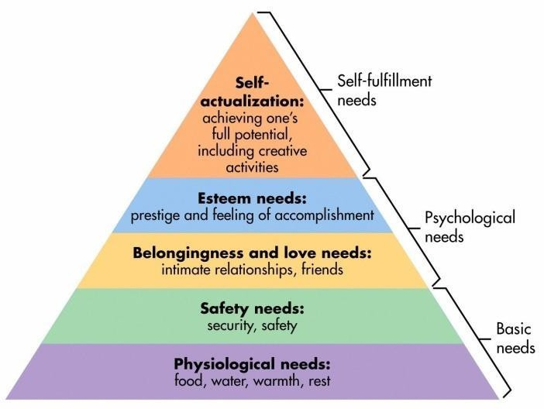

Documentation and Communication of School Support Plans
- Support plans are drafted, shared with parents for consultation, and then finalised before a programme of support commences
- Support plans are uploaded to the child’s Aladdin documents

- Any confidential information or information which evokes the implementation of the Child Safe Guarding Policy are dealt directly by the Designated Liaison Person – DLP, (or Deputy DLP in their absence), and communicated with parents/guardians.

External Agencies and Specialist Support Services
Some children and young people will require additional support from specialist support services external to the school. In the event of a child presenting with mental health concerns, which are above and beyond the capacity and ability of the school to provide adequate support, the school may decide upon either of the following courses of action:
  - Follow existing policies which enables staff to access and refer directly to an external service. In St Joseph’s NS, we have established essential relationships with local agencies and have names and contact details readily available for onward referrals.
  - When deemed necessary, the school team, with the consent and collaboration of parents/ guardians, may recommend a referral to the local General Practitioner (GP) or other appropriate professionals who can advise on referral pathways. For children with mental health difficulties, the referral will likely be made to the local HSE Psychology Service/Primary Care Team or the Child and Adolescent Mental Health Service (CAMHS).

Indicators of Success
In St Joseph’s NS, we use the Wellbeing Indicators of Success to identify our strengths and targets for improvement, and to actively monitor our progress and outcomes in relation to wellbeing promotion over time. We achieve this by accessing the opinions and views of all stakeholders throughout the process.
The Wellbeing Indicators of Success, outlined in Table 5, are the broad outcomes to which the Department aspires and wants schools and centres for education to accomplish.

Table 5: Wellbeing Promotion Indicators of Success

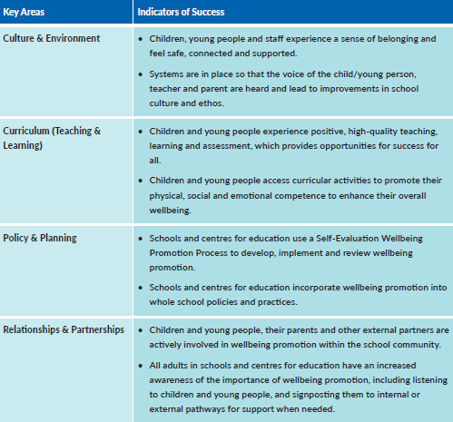

These Indicators of Success in the four key areas of wellbeing are further expanded upon as Statements of Effective Practice (See Appendix A) which provide a set of standards for wellbeing practices across the Continuum of Support at the whole school preventative level (Support for All) and also at the targeted and more individualised levels (Support for Some and Few). These Statements of Effective Practice form the basis of the school’s self-reflective Wellbeing Promotion Process. They enable us to identify strengths and areas to target and therefore plan the next stage in the improvement journey.

Suggested Measures of Success:
- Student attendance
- Successful school completion
- Successful transition of pupils
- Data gathered in school e.g. surveys, interviews, checklists
- Data gathered through consultation with children, parents, teachers and other staff members
- Information from inspectorate reports

School Self-Evaluation Wellbeing Promotion Process
To implement this policy our school is required to use the six-step School Self-Evaluation (SSE) process with the Wellbeing Policy Statement and Framework for Practice, to initiate a Wellbeing Promotion review and development cycle. We have considered our existing provision for wellbeing under each of the four key areas (culture and environment, curriculum, policy and planning, and relationships and partnerships), and are devising and implementing a plan for improvement in the key area of Culture and Environment. In devising and implementing the improvement plan, we have referred to the Statements of Effective Practice in key areas relevant to the specific focus we have chosen.
We firstly gathered information by consulting with and collecting information from key stakeholders, including staff, pupils and parents/guardians, relating to current practice in the key areas of wellbeing promotion. This information is essential in order to highlight positive aspects and strengths in our practice and identify areas for development – the analysis and judgement stage. The analysis informed actions for wellbeing in a selected area. At an intervention stage, appropriate school interventions and strategies will be generated and agreed. We will incorporate these actions into our School Improvement Plan (SIP). Steps will be put in place to implement the agreed actions. At the monitoring stage, actions will be reviewed on an ongoing basis which will assist us in evaluating impact and tracking our progress in this process of continuous improvement.

To implement this policy our school is required to use the six-step School Self-Evaluation (SSE) process with the Wellbeing Policy Statement and Framework for Practice, to initiate a Wellbeing Promotion review and development cycle. We have considered our existing provision for wellbeing under each of the four key areas (culture and environment, curriculum, policy and planning, and relationships and partnerships), and are devising and implementing a plan for improvement in the key area of Culture and Environment. In devising and implementing the improvement plan, we have referred to the Statements of Effective Practice in key areas relevant to the specific focus we have chosen.
We firstly gathered information by consulting with and collecting information from key stakeholders, including staff, pupils and parents/guardians, relating to current practice in the key areas of wellbeing promotion. This information is essential in order to highlight positive aspects and strengths in our practice and identify areas for development – the analysis and judgement stage. The analysis informed actions for wellbeing in a selected area. At an intervention stage, appropriate school interventions and strategies will be generated and agreed. We will incorporate these actions into our School Improvement Plan (SIP). Steps will be put in place to implement the agreed actions. At the monitoring stage, actions will be reviewed on an ongoing basis which will assist us in evaluating impact and tracking our progress in this process of continuous improvement.

Table 6: Using the SSE process with the Wellbeing Framework for Practice
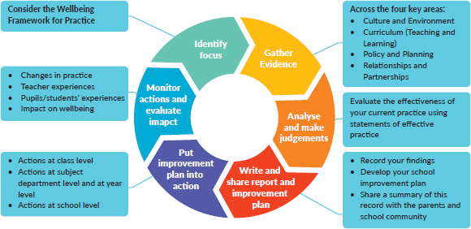

The Wellbeing in Education Framework for Practice is closely aligned to the standards set out in Looking at Our School. In order to assist schools in their use of the SSE process to engage with wellbeing, Table 7 shows how the language in the Wellbeing in Education Framework for Practice maps to the language of Looking at Our School.

Table 7: Linking Looking at our Schools and the Wellbeing Framework for Practice
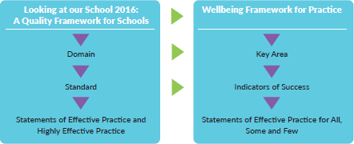

Supporting the Implementation of the Wellbeing Promotion Process
The Department have made available a suite of Wellbeing Resources to provide practical tools and information to support the Wellbeing Promotion Process.
These Wellbeing Resources include:
  - Evaluation Tools: Parent/Carer, Child/Young Person and Staff Questionnaires
  - Focus Group Guidelines to facilitate access to the voice of key stakeholders
- Revised Circular for schools to provide strengthened guidance on the use of programmes/external facilitators in school wellbeing promotion.

Continuous Professional Development
In St. Joseph’s, the school management team prioritise professional development for school staff in wellbeing promotion for staff and students. Whole-staff professional development for our school includes a focus on the following:
  - identifying and building upon existing good practice in the whole-school implementation of SPHE
  - providing a shared understanding of the wellbeing of children
  - developing an understanding of child development
  - exploring the factors that impact both positively and negatively on wellbeing
  - providing opportunities for reflection on the school environment, classroom and whole school practice to establish and maintain healthy patterns of relationships
  - raising awareness of the importance of consistency between home and school environments in the implementation of strategies and programmes which promote wellbeing
  - considering the implementation of supportive practices in addressing and resolving conflict and other issues arising between children
  - raising awareness of the links between risk taking behaviours, bullying and the development of mental health problems
  - exploring strategies to develop children’s skills, attitudes and behaviours in dealing with peer pressure, bullying situations or situations involving risk
  - equipping teachers to develop their own and children’s resilience, self-control and coping skills in a variety of social situations.

Staff Wellbeing
Support for the wellbeing of staff is also an essential element in wellbeing promotion, and crucial to sustaining teacher/staff engagement, enthusiasm and the ability to model resilience. It builds staff capacity to cope with challenges and adapt to change, and creates conditions to support and motivate staff to be effective.

St Joseph’s NS is a safe and supportive environment for staff members. All staff members are supported in maintaining their personal health and wellbeing. Our staff benefit from reflecting on our own wellbeing and general attitudes to mental health. All staff are made aware of supports for teacher wellbeing and that individual teachers requiring additional support at a particular time may access the Employee Assistance Service (EAS).

The EAS provides advice to employees on a range of issues including wellbeing, legal, financial, bereavement, conflict and mediation. It also provides advice and support to school leaders and delivers interventions to help them deal with health and wellbeing issues in the workplace.
Where appropriate, short-term counselling is available to employees and their family members. A family member includes a spouse, civil partner or dependent, where the family member can be described as a person over the age of 18 and residing at the family home. In addition, online cognitive behavioural therapy is also provided to employees.
A bespoke wellbeing portal and app is available offering a host of online services with access to live chats, videos, podcasts and blogs on topics around mental health, family life, exercise and nutrition. The platform is available via Web, iOS App or Android App.
As part of the EAS, a Mental Health Promotion Manager is also available to develop and deliver evidence based mental health and wellbeing initiatives. Spectrum Life also provides a series of webinars and presentations to promote wellbeing in schools.

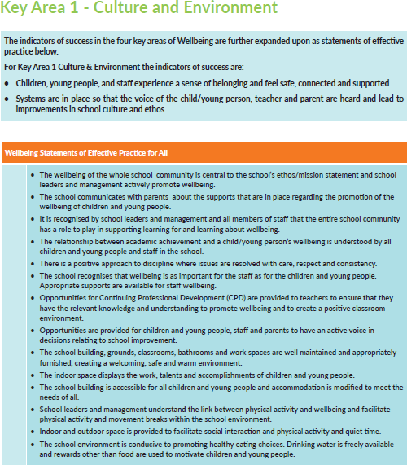
Appendix A: Statements of Effective Practice

